Chapter 1 – Introduction to Statistics

- Population – We define a population to be the set of all things that have a particular characteristic of interest, the totality of the things we are interested in. Example: How can we help students graduate faster?

Who is Interested? | Population
- US Department of Education | All students enrolled in 4-year college or university in the US
- USG Board of Regents | All students enrolled in a USG 4-year college or university
- Valdosta State University | All students enrolled in Valdosta State University

- Data – Data, loosely defined is simply a collection of information that is measured, observed, or self-reported about items in a population (or sample). We often use the terms data, data set, and even sample interchangeably.

- Variable – A variable is a characteristic that we measure or observe about items in a population in order to obtain data. In most realistic situations there are many variables that are of interest for a particular situation.

- Example 1:
- Question: How long does it take students to graduate?
- Population: All VSU students who graduated Spring 2014
- Variables: sex, number of semesters to graduate, GPA, number of hours taken each semester, SAT score, etc.

- Example 2:
- Question: How long does it take a customer at a drive-through from the time they enter the line to the time they drive away?
- Population: All customers who use the drive-through during lunch hours (11:30-12:30) on weekdays.
- Variables: Total time, time to order, waiting time, service time, number of people in vehicle, total price of items.

- Some variables are:

- Measured – service time at a drive through, weight of a tomato, height of a plant, speed of a CPU, breaking strength of a steel beam, etc.

- Observed – sex of a driver, color of a car, using a cell phone or not, presence of a defect on a product or not, etc.

- Self-Reported –We may be interested in the amount of money people spend on clothing in a year. We could certainly measure this but it would be very time consuming. In such a situation we might ask randomly selected people to go back over their credit card statements and estimate how much they spent on clothing in the last year. Self-reported data is usually not as accurate as data that is directly measured or observed.

- Census – A census is when we measure (or observe) every item in the population. In theory, a census provides exact information about a population. Some problems are amenable to using a census.

- In the case of studying graduation rates in the USG, we can obtain exact information on a number of variables due to records being kept in databases and the relatively low cost of querying the databases.

In other cases, it is too time consuming and/or expensive to do a census.

- In the case of studying the total volume of lumber contained in a 500-acre tract of land, it would be very time consuming and expensive to measure the height and diameter of every tree on the tract.

- Sample – When it is not feasible to conduct a census, we use a sample which is a subset of the population that is (usually) chosen so that it is representative of the population in some way.

- Question: How do VSU students rate the extra-curricular opportunities offered?
Population: All full-time VSU students enrolled in the Spring 2014 semester.
Sample: Send the survey to all students. The ones that respond are the sample.

- Question: What is the public’s sentiment about a proposed bill before congress
Population: All registered voters
Sample: Select registered voters at random until 2000 people have answered the survey. (Almost all national opinion polls survey 1000-2000 people chosen randomly.)

- Question: Do manufactured products conform to required standards
Population: all products coming off an assembly line
Sample: Every 50th product is pulled for testing to see if it conforms to standards.

- Representative Sample – When we use a sample, we are not using every item in the population, so we want the sample to be representative of the population so that we can have confidence in conclusions we draw about the population.

- A sample of the first 20 products that came off an assembly line during a day’s production would probably not be representative; there may be a warm-up effect occurring as the machines get up to speed.

- A survey 100 residents of mid-town Atlanta to learn about purchasing habits would not be representative of the entire population of Atlanta.

- A survey of students in evening classes might not be representative of the entire student population.

A biased sample doesn’t represent the population as a whole and thus leads to biased conclusions about a population. Later, we will consider this further.

- The population should be carefully and accurately defined.

- We don’t want to define the population as, “all 18-24 year-olds in the US” if we can only obtain data from students at VSU.

- When we use a sample, we know there is error in our results for the simple reason that we did not measure every element in the population. However, as we will learn, statistical inference allows us to quantify the error in a sample.

- A survey of 2000 voters revealed that 63% support a particular candidate with a margin of error of 3%.

- Statistic – A statistic is simply a number, graph, or table that summarizes data.

- Science of Statistics – The science of statistics is the study of how we collect, analyze, interpret and present data.

- Types of Populations

- A concrete population is one where we can (in theory) directly identify (measure) every item in the population. Examples:

- Pine trees in Georgia. Variables: height, volume, age, etc.
- People 18-24 years old that reside in the United States (about 27 million). Variables: height, weight, SAT, salary, etc.
- 4-year non-profit colleges and universities in the US (about 2170). Variables: tutition, enrollment, etc.
- Cell phones in the world (about 6 billion), land-lines in the world (about 1.2 billion). Variables: length of phone calls.
- Ponds in Lowndes County. Variables: volume, surface area, etc.

- A conceptual population is one where the data (items) are part of an ongoing process.

- Customers arrive at the drive-through, hour after hour, day after day. Variables: length of time to place an order, length of time to receive order.
- The bottles of soda that come off a filling line. Variable: amount of liquid in bottle.
- People that get their hair cut at a salon. Variable: length of time to cut hair.
- The amount of CFC’s in the atmosphere.

- Using Statistics: You use a statistics to help you make informed judgments and decisions about a population. Statistics are used in every type and aspect of business including service, sales, marketing, public relations, human resources, advertising, product design, engineering, manufacturing, and others. Every business, government entity, or non-profit uses statistics either in an informal or formal way.

- The former VSU President (2002-2008), Dr. Ronald Zaccari was well-known for his use of data to make decisions. As the population of VSU students grew under his tenure, it was observed that there was a problem with students crossing Patterson Street at the main entrance to campus (conceptual population). There was no traffic signal nor cross walk there at the time. Several students were hit by cars and there were a number who were nearly hit. Patterson Street is a state highway (GA 31), thus, is under the purview of the Georgia Department of Transportation (GDOT). Dr. Zaccari wanted to have a traffic light and cross walks installed. The GDOT required that he submit data about the problem before they would consider solutions. Through sampling, he found that around 3000 people crossed Patterson Street daily. Based on that and other statistics, he was able to convince the GDOT to install a set of traffic lights and crosswalks. He used a similar approach to promote the idea of creating the pedestrian mall running through campus by measuring the amount of car traffic and delays.

Statistics is also invaluable in the scientific world to gain understanding of how our world works. Statistics is used in every area of science including biology, geology, archeology, psychology, sociology, forensics, and others. Statistics is used extensively in education as well as the arts.
1.2 – Types of Data

- These are the types of data we will consider. (There is a fourth type, ratio, that is related to quantitative which we will not consider).

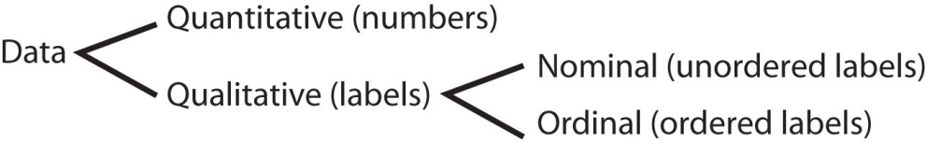

- Quantitative data – Quantitative data are measures of something. The data values are numeric. The arithmetic difference between two data values measures how much more or less there is when the two values are compared. Examples of quantitative variables:

- height of a pine tree
- weight of a tomato
- volume of soda in a can
- length of a phone call
- speed of a computer processor
- distance between two molecules
- the time that a drug takes to absorb into the bloodstream.

- Qualitative Data – Some data are not actually measured, they are simply observed and we usually give labels to these observations. For example if I am observing the sex of people who shop at a store, I might record the data in any of these forms which all convey the same meaning:

- {Male, Female, Female, Male, Male, Male, Female}
- {M, F, F, M, M, M, F}
- {Yes, No, No, Yes, Yes, Yes, No}

Thus, with qualitative data, the data values themselves are simply labels. We can count qualitative data values, but we can’t do arithmetic operations on the values. Qualitative data is sometimes called categorical data. Qualitative data can be broken down into two types:

- Nominal Data – The data values cannot be ranked (ordered). Examples:

  - sex – { Male, Female }
  - occupation – { Engineer, Manufacturing, Service, Other }
  - color of car – { Red, Blue, Tan, Black, White, Other }
  - presence of a defect in a product – { Present, Not Present }
  - wearing sun glasses – { Wearing, Not Wearing }

- Ordinal Data – The data values can be ranked. Examples:

  - grades for a course {A, B, C, D, F}
  - student rank in class { “first”, “second”, “third” }
  - SOI (Student Opinion of Instruction), e.g. course ratings – each question is answered with a response between 1 and 5 corresponding to: 5 (strongly agree), 4 (agree), 3 (neutral), 2 (disagree), and 1 (strongly disagree).
  - Survey card in a restaurant, “How was your service today? poor, fair, ok, good, great.”
Student | Sex | Final Avg. | Grade | Rank
Anna | F | 83.7 | B | 4
Jean | F | 97.9 | A | 1
Walt | M | 73.3 | C | 6
Cindy | F | 86.2 | B | 3
Sam | M | 97.3 | A | 2
Dave | M | 79.6 | B | 5
- Example – Consider the data set shown on the right.

- Sex is a nominal variable (qualitative),
- Final Avg is quantitative
- Grade and Rank are both ordinal variables (qualitative). You may be tempted to say that Rank is quantitative because you can calculate differences between the values (as required for quantitative data); however, the differences don’t have a consistent meaning. For example, Anna and Sam have a difference in rank of 1 as do Sam and Cindy. However, their respective differences in Final Averages is not consistent: 0.6 (97.9-97.3) for Anna and Sam while it is 11.1 11.1 (97.3-86.2) for Sam and Cindy. Thus, this variable is ordinal, not quantitative.

- Example – Consider a restaurant survey as shown below. You are asked a to rate variables on a scale from 0 to 5. Above each number, we usually see descriptions like, “Not at all important”, …, “Very Important”. Thus, the data are labels and can be ranked so the data is ordinal.

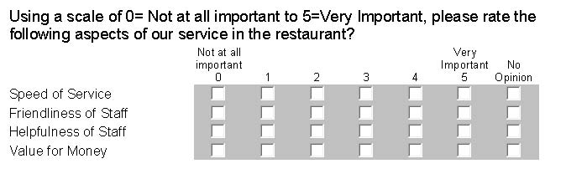

- Scales of Measurement – The amount of information contained in data can be classified in terms of its strength. The stronger data is, the more information that is available, and the more potential to learn from it. Quantitative data has the most information, followed by ordinal, and then nominal. In other words, you can gain more insight into a subject when you have quantitative data as compared to qualitative. Similarly, ordinal data has more information that nominal data.

- For example, suppose a small part in a toy is required to have a width of 10 mm with a tolerance of 0.5 mm. We learn more about the process that produces the parts by measuring the width of a sample of parts as opposed to simply classifying each part in the sample as defective or not defective.
1.3 – Sources of Data

Where do we get data?

- Historical – This is sometimes referred to as past data. It is data that already exists in databases on computers, or sheets of paper in a filing cabinet, etc. On the internet you can find historical data on almost any subject you can imagine.

- Observational – We observe the subject that we are interested in to collect data in the present. In this situation we do not manipulate the subjects in any way, we simply observe. For instance, we may time how long a shopper spends in a store.

- Experimental – This type of data results from designed experiments and computer simulation. This type of data promotes advances in science, medicine, and engineering. In designed experiments, we usually manipulate the subjects in some way. Examples:

- In the study of a drug’s effectiveness, we might gather a random sample of people that have a symptom(s) that the drug might cure. Half the subjects are given the drug and the other half is given a placebo. However, all subjects are lead to believe they are taking a drug that will cure their symptom. Often, doctors who monitor the subjects during the experiment don’t know which patients have received the placebo.

- If we are studying a plant fertilizer, we might alter the amount of fertilizer that we give to groups of plants in order to see what the optimal amount is to produce growth.

- Computer simulation involves using a computer to simulate some physical phenomena. For instance, computer simulation is used to help decide how to arrange products in a warehouse, how many people are needed to pick orders, and how to batch orders to give to an order picker. It would be very expensive and time consuming to physically experiment with a real warehouse so computer simulation is used to evaluate different configurations of product arrangement, number of order pickers, and strategies for batching orders.

In this course, we will mostly consider historical and observational data. More advanced statistical techniques are used to evaluate experimental data.

1.4 – Basic Definitions 3

- Simple Random Sample (SRS) – In statistics there are lots of ways to obtain a sample. The simplest type of sample, and the one we will use almost always in this class is called a simple random sample (SRS). An SRS is chosen by making sure that the following three conditions are met:

- Each item selected comes from the same population
- Each item is selected independently of the others.
- Each item in the population has an equal chance to be in the sample.

Let’s consider these conditions in more detail:
- Each item selected comes from the same population

This sounds simple, and often is. But things can get contaminated sometimes. Sometimes, a data value will be unusually large or small. Such a value can drastically influence the statistics we compute from the data. When we find such a value, we might decide upon careful analysis that it doesn’t belong to the population and should be excluded from the sample.

- Suppose that you are studying how long it takes a person to check their bags and obtain their ticket upon arrival to the Delta ticket counter at the Jacksonville airport. Suppose that you time peoples’ waits and almost all are between 3 and 7 minutes. However, one person doesn’t speak English and a translator must be paged. This person’s time ends up being 45 minutes. You might argue that this person doesn’t belong to the population you are studying. If so, technically, we should modify the description of the population to say that we are only studying people speaking English.
You also want to be proactive to prevent this type of contamination.

- For instance if you were studying how much individuals spent on goods at Sams for their personal consumption, then you would want to have a sampling plan that made sure you did not take data from someone buying products for a business.

- Each item is selected independently of the others.

What this means is that each data value does not influence the value of any other data value.

- Suppose you want to study how fast people walk. You decide to measure and mark a distance of 20 feet along a sidewalk. Then, you time random people as the walk this distance. However, you would need to be more specific in your definition of your population. Are you timing individual people or groups of people? If you were interested in individual people, the you would not time separately, two people who were walking together as their times would be dependent.

- Suppose you want to study how long people have to wait in line to checkout at a grocery store. You would not want to collect data from two people who are in the line one after the other because the second person’s wait time depends on the first person’s wait time. These two people are not independent. One way you could do this would be to randomly pick a line and time the next person who gets in that line. Once the person has finished, then you randomly pick another line and start the process over again.

However, if we were studying the service time, the time it takes the cashier to scan the groceries, bag them, and accept payment, then we would not run into this problem. Why?

- Each item in the population has an equal chance to be in the sample.
Conceptually, this is very simple to do. Give every item in your population a unique number. Then put all the numbers on pieces of paper, put them in a hat, shake it up, and then choose say 50 numbers from the hat. Then, the items corresponding to the 50 chosen numbers comprise the sample. Such a sampling plan ensures that each item in the population has an equal chance to be in the sample. In practice, this is harder to do.

- Suppose we want to survey what adults in America think about a bill pending before Congress. Suppose we decide to use a telephone survey. Not all adults have a telephone. But telephone surveys are done and are often very accurate. How are phone numbers picked? Telephone surveys typically utilize computer programs to create random phone numbers and dial them. This ensures that people with unlisted phone numbers will be sampled as well as people with listed numbers. However, such a sample doesn’t perfectly represent the population.

- Suppose you had a cage with 100 rats and you want to choose a sample of 10. What is wrong with using the first 10 rats you can catch?

- Outlier - An outlier unusually large or small data value. We will learn several techniques to detect outliers. When we detect an outlier, we must ask if it belongs to the population. If the answer is “yes”, we usually keep the outlier. If the outlier is determined to be from some other population, we discard it. Sometimes an outlier is a part of the population, but we have a strong reason to exclude it. In either case, we always document the removal of the outlier.

- Many companies practice quality improvement programs where a group of employees will study a problem area in the company. One tenet of such programs is that to change something, the first step is to measure it. When outliers are detected the group will study them to find the cause(s) of the outlier. If the outlier is not desired, then the company can consider steps to eliminate (reduce) the conditions that caused the outlier.

- Descriptive Statistics – Descriptive statistics summarize a sample. We use tables, graphs, numbers, percentages, averages, etc. to summarize the information in a sample and all of these are descriptive statistics.

- Statistical Inference – Statistical inference refers to the process of using the information in a sample (descriptive statistics) to make a statement about a population or evaluate a claim about a population. This statement is usually accompanied by a margin of error.

Chapter 2 – Descriptive Statistics

This chapter discusses how to compute and interpret descriptive statistics for quantitative data.

2.3 – Overview of Exploring Quantitative Data

Now, we will consider descriptive statistics for quantitative data. Before we begin with the techniques, let’s discuss some things we look for when analyzing quantitative data:

- The center of the data. What is the average of the data? The median?
- The spread of the data. How spread out is the data? Or how tightly grouped is the data? Does the data range from 2.5 to 4.3 seconds? Or does it range from 2.5 seconds to 56.3 seconds?
- The shape of the distribution and whether the data is symmetric or skewed. How is the data distributed? Are there a lot of small values and a few large values? Or a few small values and a lot of large values? Or are there approximately an equal number of small and large values?

We’ll learn more about these throughout this chapter. We will also see how we can use the various descriptive statistics to answer these questions.

2.4 – Measures of Central Tendency

- Sample Size – We use the symbol n to denote the number of items in a sample and refer to this as the sample size.

- Data Labels – As shown below, each data value is assigned a label. Many times the label is not shown and just understood to be there. It is convenient to introduce the idea of data labels so that we can understand the formulas that follow. In the example below, $x_{1}=4$ refers to the first data value. Similarly, $x_{2}=9$ refers to the second value.

Sample (Data) | 4 | 9 | 3 | 6 | 5
Data Labels | $$x_{1}$$ | $$x_{2}$$ | $$x_{3}$$ | $$x_{4}$$ | $$x_{5}$$

- Sample Average – We use the symbol, $\overline{x}$ to denote the sample average. The sample average is also called the: average, sample mean, mean, x-bar. It is the numerical average of the data values obtained by adding up all data values and dividing by the sample size. The sample average is calculated with this formula: $\overline{x}=\frac{1}{n}\sum_{i=1}^{n}{x_{i}}$.

Note: The capital Greek letter $Σ$ (sigma) in mathematics means, “add up the values to the right of it”. For instance, $\sum_{i=1}^{n}{x_{i}}$ means “add up all the x's from the first one (i=1) to the last one (n).”

Example (using data from table above): $\overline{x}=\frac{1}{5}\sum_{i=1}^{5}{x_{i}}=\frac{1}{5}\left(4+9+3+6+5\right)=\frac{1}{5}\left(27\right)=5.4$

- Median, M - is the middle data value which means that approximately 50% of the data have values less than the median and 50% have values greater than the median. Steps to find the median of a data set:

Steps to calculate median:

- Sort data, smallest to largest.
- Re-label sorted data.
- Determine whether sample size (n) is odd or even.

  - If $n$ is odd, then median is middle observation,

Calculate $i=\frac{n}{2}$, then round i up to the next integer. Finally, $M=x_{i}$

  - Else if $n$ is even, then median is the average of two middle observations.

Calculate $i=\frac{n}{2}$, then. Finally, $M=\frac{x_{i}+x_{i+1}}{2}$

- Examples

2 | 8 | 12 | 9 | 5 | 6 | 4
- Find the median of the following data:

- Sort and
- Relabel data:

i | 1 | 2 | 3 | 4 | 5 | 6 | 7
 | 2 | 4 | 5 | 6 | 8 | 9 | 12

- Case a. Since the sample size is odd, $n=7$, calculate $i=\frac{n}{2}=\frac{7}{2}=3.5$, Then round i up so that $i=4$. Finally, the median is $M=x_{i}=x_{4}=6$.

- Find the median of the following data:

2.4 | 8.3 | 12.1 | 9.6 | 5.2 | 6.8 | 4.7 | 11.2 | 10.4 | 4.9

- Sort and
- Relabel data:

i | 1 | 2 | 3 | 4 | 5 | 6 | 7 | 8 | 9 | 10
 | 2.4 | 4.7 | 4.9 | 5.2 | 6.8 | 8.3 | 9.6 | 10.4 | 11.2 | 12.1

- Case b. Since the sample size is even, $n=10$, calculate $i=\frac{n}{2}=\frac{10}{2}=5$. Thus, the median is the average of the 5th and 6th data values: $M=\frac{x_{i}+x_{i+1}}{2}=\frac{x_{5}+x_{6}}{2}=\frac{6.8+8.3}{2}=7.55$.

- Outliers – An outlier is defined to be an extremely large or small data value. The median is said to be resistant to outliers. What this means is that the median is not as influenced by an outlier(s) compared to the sample mean. We also say that the sample mean is not resistant to outliers. Later, we will see two methods to detect possible outliers: boxplots and z-scores.

When salaries (and house prices) are reported in the media, the median is almost always stated, not the average. Why is this so?

2.5 – Numerical Descriptive Statistics on TI-83 Calculator

This section provides instructions on how to use the TI-83/84 calculator to obtain various numerical descriptive statistics. The calculator uses Lists to store data. Lists have names like "L1", "L2", etc and are arranged in columns.

- Display the List window:

- Press the Stat key | 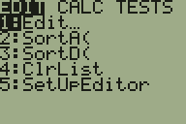
- Chose Edit by pressing the 1 key | 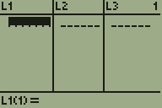

- If there is data in L1, clear the list:

- Press the Up Arrow key which highlights L1. | 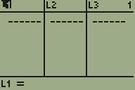
- Press the Clear key and Enter

- Enter data:

Type a number and press Enter, repeat. Enter these values:  7, 39, 13, 9, 25, 8, 22, 0, 2, 18, 2, 30, 7, 35, 12, 15, 8, 6, 5, 29, 0, 11, 39, 16, 15. | 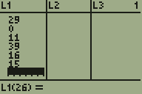

- You can sort the data if you want to.

- Press the Stat key:
- Choose SortA by pressing the 2 key. | 
- Supply the list you want to sort. To sort L1, press the 2nd key and then the 1 key and the press Enter.
- Press the Stat key and then the 1 key to see the data sorted.

- Display descriptive statistics:

- Press the Stat key
- Use the right-arrow key to move over Calc. | 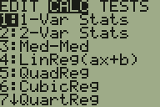
- Press the 1 key for 1-Var Stats | 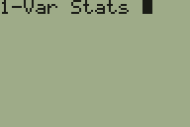
- Supply the list you want to use. To use L1, press the 2nd key and then the 1 key | 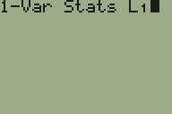
- Press Enter | 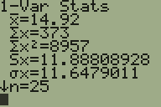
- Use the down-arrow key several times to see more of the display. | 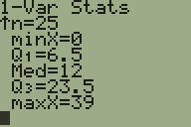

Your window will show these descriptive statistics. We will learn about the ones in red.

Symbol | Value | Comment
$\overline{x}$ | 14.92 | Sample Average
$\sum{x}$ | 373 | Not considered
$\sum{x^{2}}$ | 8957 | Not considered
$s_{x}$ | 11.888 | Sample standard deviation
$σ_{x}$ | 11.648 | Not considered
$n$ | 25 | Sample size
$\min{x}$ | 0 | Minimum
$Q_{1}$ | 6.5 | First Quartile
$Med$ | 12 | Median
$Q_{3}$ | 23.5 | Third Quartile
$\max{x}$ | 39 | Maximum

Homework 2.2

- The data below shows the number of hours per week that a sample of men and women studied while taking a full load of classes at a university. The times are recorded in hours and include the time spent in the classroom as well as studying outside of class. (Use Calculator) (a) Compare the averages for men and women. (b) Compare the medians for men and women.

Men
  43.2 | 28.7 | 44.9 | 29.3 | 31.7 | 29.8 | 54.3 | 30.1 | 30.9 | 31
  29.7 | 31.1 | 32.1 | 51.7 | 32.2 | 34.3 | 34.4 | 34.9 | 35.3 | 30.4
  36.2 | 36.4 | 56.6 | 37.4 | 39.2 | 60 | 41.4 | 41.9 | 44.3 | 41.2
  35.8 | 41.5 | 47.9 | 28.2 | 49.3 | 29.5 | 55.2 | 38.5 | 58.1 | 47.5
Women
  48.1 | 48.7 | 47.5 | 33.8 | 40.3 | 46.1 | 54.2 | 55.2 | 41.5 | 46.7
  61.2 | 45.4 | 50.4 | 43.1 | 51.2 | 34 | 54.1 | 47.9 | 58.3 | 41.3
  53.8 | 54.2 | 44.6 | 48.3 | 33.9 | 43 | 44.4 | 57.2 | 27.5 | 45.1
  43.6 | 48 | 40 | 36.6 | 47.9 | 43.8 | 34.8 | 30.5 | 44.2 | 46.3

2.6 – Measures of Location

- $p^{th}$ Percentile – The $p^{th}$ percentile is the number such that approximately $p$ percent of the data have values smaller than it and approximately $\left(100-p\right)\%$ of the data have values larger than it. Thus, if the 90th percentile on a test is 86, this means that approximately 90% of people scored less than 86 and 10% scored more than 86. The percentile is not usually one of the actual data values.

- Steps to Calculate a Percentile – Suppose you have $n$ data values and you want to calculate the $p^{th}$ percentile.

  - Sort data, smallest to largest.

  - Label sorted data: $x_{1}, x_{2},…, x_{n}$

  - Calculate the index, $i=p∙n$, where $p$ is the percentile you want to calculate (expressed in decimal form).

  - Determine whether the index, $i$ is an integer or a decimal number.

    - If $i$ is an integer then the $p^{th}$ percentile is the average of the data values in positions $i$ and $i+1$: $p^{th} percentile=\frac{x_{i}+x_{i+1}}{2}$

    - If $i$ is a decimal then round $i$ up to the next integer value and then the $p^{th}$percentile is the $i^{th}$data value: $p^{th} percentile=x_{i}$

- Percentile Examples – Consider the data shown in the table below (Original Data) which represents salaries (in $1000’s) for recent college graduates in the computer science field. Find the following percentiles: (a) 10th (b) 25th (c) 75th (d) 80th (e) 87th. First, sort and relabel the data.

 | - 10th percentile:$i=p*n=0.1\left(30\right)=3$  Since $i$ is an integer, the 10th percentile is:  $$\frac{x_{i}+x_{i+1}}{2}=\frac{x_{3}+x_{4}}{2}=\frac{29.6+30.2}{2}=29.9$$  - 25th percentile: $i=p*n=0.25\left(30\right)=7.5$  Since $i$ is not an integer, we round $i$ up so that $i=8$. Finally, the 25th percentile is: $x_{i}=x_{8}=31.3$  - 75th percentile: $i=p*n=0.75\left(30\right)=22.5$  Since $i$ is not an integer, we round $i$ up so that $i=23$. Finally, the 75th percentile is: $x_{i}=x_{23}=38.5$  - 80th percentile:$i=p*n=0.8\left(30\right)=24$  Since $i$ is an integer, the 80th percentile is:  $$\frac{x_{i}+x_{i+1}}{2}=\frac{x_{24}+x_{25}}{2}=\frac{38.7+40.3}{2}=39.5$$  - 87th percentile:$i=p*n=0.87\left(30\right)=26.1$  Since $i$ is not an integer, we round $i$ up so that $i=27$. Finally, the 87th percentile is: $x_{i}=x_{27}=42.1$
  Data |  | Sorted
  $$i$$ | $$x_{i}$$ | $$i$$ | $$x_{i}$$
  1 | 34.4 | 1 | 24.7
  2 | 31.2 | 2 | 28.4
  3 | 32.1 | 3 | 29.6
  4 | 31.3 | 4 | 30.2
  5 | 35.6 | 5 | 30.5
  6 | 38.7 | 6 | 31.1
  7 | 38.0 | 7 | 31.2
  8 | 40.3 | 8 | 31.3
  9 | 35.3 | 9 | 32.1
  10 | 41.4 | 10 | 32.8
  11 | 35.6 | 11 | 33.2
  12 | 32.8 | 12 | 33.2
  13 | 24.7 | 13 | 33.4
  14 | 44.1 | 14 | 34.4
  15 | 29. | 15 | 35.1
  16 | 38.5 | 16 | 35.3
  17 | 33.2 | 17 | 35.5
  18 | 28.4 | 18 | 35.6
  19 | 33.4 | 19 | 35.6
  20 | 42.9 | 20 | 37.4
  21 | 33.2 | 21 | 38.0
  22 | 30.5 | 22 | 38.1
  23 | 37.4 | 23 | 38.5
  24 | 35.5 | 24 | 38.7
  25 | 31.1 | 25 | 40.3
  26 | 35.1 | 26 | 41.4
  27 | 42.1 | 27 | 42.1
  28 | 30.2 | 28 | 42.1
  29 | 38.1 | 29 | 42.9
  30 | 42.1 | 30 | 44.1

- Quartiles – Several percentiles have special names:

- First Quartile is $Q_{1}={25}^{th} percentile$
- Second Quartile is $Q_{2}={50}^{th} percentile$ (the Median)
- Third Quartile is $Q_{3}={75}^{th} percentile$

Example – The first quartile for the data above is $Q_{1}=31.3$ and the third quartile is $Q_{3}=38.5$

- 5-Number Summary – The 5-Number Summary for a data set is these five numbers:

$$Minimum, Q_{1}, M, Q_{3}, Maximum$$

From the 5-number summary, we can see the distribution of the data in a number of ways. For instance, the third figure shows the data broken into 4 regions where each region contains the same amount of data (25%). Note that the width of these regions is unequal in general. This is useful to show us where the data may be clumped up, spread out, or evenly distributed. The figure below summarizes the 5-Number Summary.

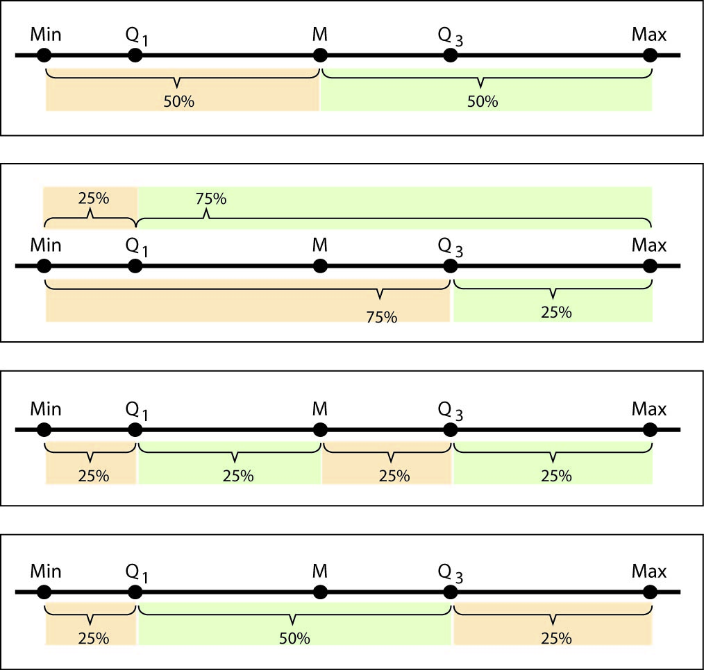

- Example, continued from data above:

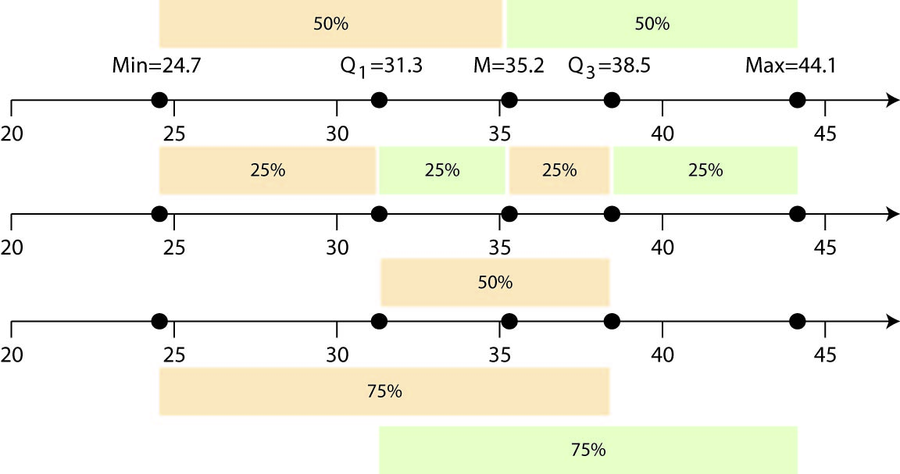

Some things we can observe from this 5-number summary above:

- about 50% of salaries fall between $31,300 and $38,500,
- 25% of salaries are less than $31,300,
- 25% of salaries are greater than $38,500,
- Half the salaries are above $35,200.
- The third quartile is more tightly grouped than fourth quartile.
- The center most 50% of the data is more tightly grouped than outer values.

Homework 2.3

- Consider the data from Homework 2.2. (a) Make a chart of the following values for men and women: first quartile, third quartile, 63rd percentile, and 80th percentile. (b) Study the chart and write some sentences that summarize what you observe. Can you make some comparisons between the men’s and women’s values?

- Compare the minimum and maximums for the data from Homework 2.3.

- Consider the 5-number summaries shown below for two samples of data. Make some statements that compare these two samples.

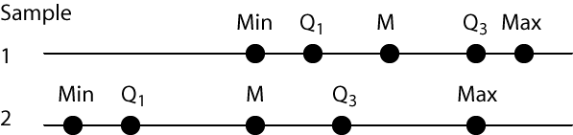
2.7 – Measures of Spread (Variation)

When we collect data, say the time it takes to get an order at a drive through, all the values are different. Each order takes a different amount of time to fill. So, a natural question is, how much do the values vary? For instance, the high temperatures in July in Valdosta may vary from 89-100 degrees whereas the high temperatures in January may vary from 28-55 degrees. Which month has more variability in temperatures. In this section we consider several numerical measures of how much variability there is in the data. By doing this, we can determine how spread out the data is or how tightly grouped it is.

- Range – The range is the difference between the largest and smallest data values, $R=Maximum-Minimum$

- Interquartile Range – This is the range of the centermost 50% of the data, $IQR=Q_{3}- Q_{1}$. This value is more resistant to outliers than the range.

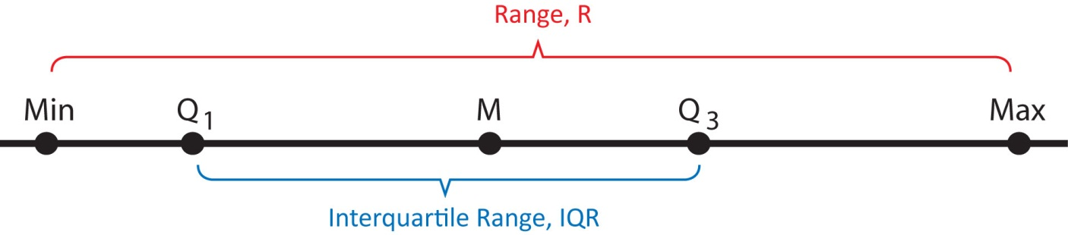

- Sample Variance and Standard Deviation – We use the sample variance and sample standard deviation as measures of the variability in data.
$$s^{2}=\frac{1}{n-1}\sum_{i=1}^{n}{{\left(x_{i}-\overline{x}\right)}^{2}}$$ | Sample Variance
$$s=\sqrt{s^{2}}$$ | Sample Standard Deviation

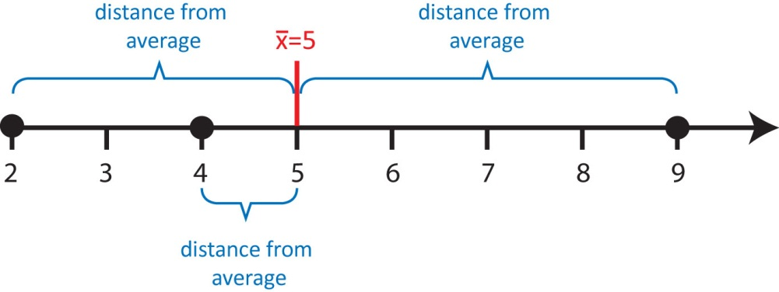
Let’s take a closer look at the formula for variance. Suppose we have the dataset: 2, 4, 9. What is the variance and standard deviation? The sample average of this data is 5. The formula for the standard deviation says:

- See how far each data value is from the average: $x_{i}-\overline{x}$

- Square each of the distances: ${{(x}_{i}-\overline{x})}^{2}$

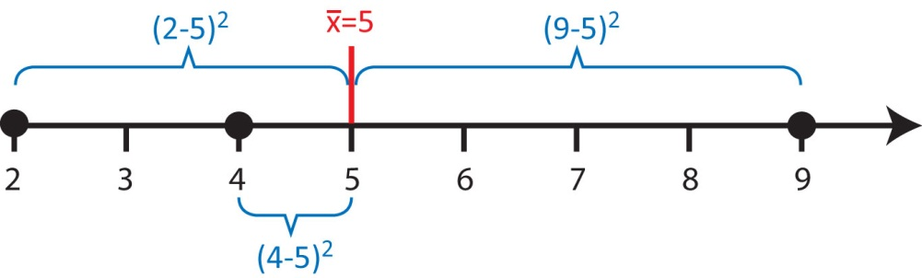
- Add up the squared distances: $\sum_{i=1}^{n}{{\left(x_{i}-\overline{x}\right)}^{2}{=3}^{2}+1^{2}+4^{2}=26 sec^{2}}$

- “Average” the squared distances to obtain the sample variance:

$s^{2}=\frac{1}{n-1}\sum_{i=1}^{n}{{\left(x_{i}-\overline{x}\right)}^{2}}=\frac{1}{3-1}26=13 sec^{2}$

Thus, in some sense, sample variance is the average squared distance of data values from their average. We can see from the formula that the larger the sample variance (or standard deviation), the more spread out the data is.

- Take square-root to obtain sample standard deviation: $s=\sqrt{13 sec^{2}}=3.6 sec$

The units of standard deviation are units of the data, for instance, sec in the example above. In statistics, we almost always use the sample standard deviation as opposed to the sample variance.

Thus, in some sense, sample standard deviation is the average distance of data values from their average.

Previously, we showed the numerical descriptive statistics display on the TI-83 calculator. There, the symbol, $s_{x}$ is used to represent the standard deviation. Most statistical software and your TI-83/84 calculator only report the standard deviation. The sample variance, of course can be calculated by squaring the standard deviation.

- Examples – A study was done to see how long people spend in Applebees and Ryans. The Range, IQR, and standard deviation are shown for each data set in the table below (all data is in minutes):

 | Range | IQR | Standard Deviation
Ryans | 129 | 25.8 | 24.5
Applebees | 42 | 10.5 | 10.3

Thus, we see that the variability at Ryans is more than twice the value at Applebees as shown by any of these measures of variability. Can you think of reasons why there might be more variability at Ryans compared to Applebees? (Ryans is a buffet restaurant and Applebees is a restaurant where you order from your table). Can you think of why this information might be useful to someone opening a restaurant?
Homework 2.4

- Consider the data from Homework 2.2. (a) Make a chart of the following values for men and women: Range, standard deviation, and inter-quartile range. (b) Study the chart and write some sentences that compare the spread for men and women.

2.8 – Making a Histogram

- Histogram – A histogram is a graphical representation of the data that is similar to the bar chart we considered with qualitative data: it shows the distribution of data into different groups. The general idea is to:

- Divide the data into groups (classes),
- Count the data values in each group (class),
- Graph the counts (or relative frequencies) using bars.

- Example – Consider the salary data shown below which is a sample of size $n=50$, showing the starting salary (in thousands of dollars) of recent Computer Science graduates:

19.5 | 26.8 | 29.1 | 30.5 | 31.5 | 32.2 | 33.2 | 33.9 | 35.4 | 37.4
24.2 | 27.4 | 29.1 | 30.9 | 31.9 | 32.4 | 33.3 | 34.8 | 36.1 | 39.2
24.8 | 27.8 | 29.6 | 30.9 | 32.1 | 32.5 | 33.3 | 34.9 | 36.1 | 39.7
25.3 | 27.8 | 30.1 | 31.1 | 32.1 | 32.8 | 33.4 | 35.0 | 36.3 | 40.2
25.7 | 28.6 | 30.3 | 31.4 | 32.1 | 33.1 | 33.4 | 35.3 | 36.9 | 41.0

If we decide to define the classes as shown in the table below, we see that there is one salary in the range $\$18,000<salary<\$22,000$ and 4 salaries in the range, $\$22,000≤salary<\$26,000$, etc. We can also calculate the relative frequencies by dividing each frequency (count) by the sample size.

 | Frequency Distribution | Relative Frequency Distribution
Class | Frequency (count) | Relative Frequency
(18,22) | 1 | 1/50 = 0.02 = 2%
[22, 26) | 4 | 4/50 = 0.08 = 8%
[26, 30) | 8 | 8/50 = 0.16 = 16%
[30, 34) | 23 | 23/50 = 0.46 = 46%
[34, 38) | 10 | 10/50 = 0.20 = 20%
[38, 42) | 4 | 4/50 = 0.08 = 8%
 | n = 50 | sum = 100%

The graph on the left is the frequency histogram where the height of each bar is the count of the number of data values that fall in that class. The graph on the right is a relative frequency histogram and shows the percentage (or fraction) of data that falls in each class.
We notice that no matter whether we use the frequencies or the relative frequencies to draw the histogram, the shape is the same. In this case, we notice that the histogram is symmetric and bell-shaped (mound-shaped). Symmetric means that we can draw a line down the middle of the graph and the two halves are approximately mirror images of one another. When we say that day has a bell-shaped distribution, this implies that it is symmetric but it also conveys to us that relatively, most of the data is clustered around the center, but there are a few relatively small and large values.

- Guidelines for making a histogram:

- Choose number of bars (classes, groups, intervals). Choose between 5 and 20. A histogram is sensitive to the number of classes, so you may want to try several values in practice. A rule-of-thumb is to use about $\sqrt{n}$ classes for a histogram.

- A sample size of 30 means $\sqrt{30}=5.477$, thus we might use 5 or 6 classes in the histogram.
- A sample size of 250 means suggesting we might want anywhere from 14, 15, or 16 classes.

- Determine class width, beginning point of histogram and ending point. Keep in mind that:

- Classes have no overlap.

- The lower limit of the smallest class is usually less than the smallest data value. The upper limit of the largest class is usually greater than the largest data value. However, if the data cannot be negative, it doesn’t make sense to choose a starting point less than 0.

There is no single correct value for class width. A good place to start is to use this formula:

$approximate class width=\frac{Maximum-Minimum}{number of bars}=\frac{R}{number of bars}$

- For instance, considering the salary data above, there are 30 data values so we will begin with 6 bars. Thus, $approximate class width=\frac{41-19.5}{6}=3.58$ so that each bar represents $3,580. However, if we adhere to rule b.ii above, we need to choose a value a little larger than 41 for the ending point and a little smaller than 19.5 as the beginning point. If we choose 42 and 18, respectively, we see that the class width is $\frac{42-18}{6}=4$. Thus, the first class will go from 18 to 18+4, i.e. (18, 22). The second class will go from 22 to 22+4, i.e. [22, 26) as shown in the table above.

- Construct the frequency and relative frequency distributions.

- Graph the relative frequency distribution.

- Choosing Class Limits
Note that your calculator and the software we will use on a computer will automatically compute a histogram for us and thus, automatically compute class widths and starting and ending points. This is a good place to begin, but then we usually alter these values a bit to make the class widths (and/or starting and ending points) more understandable.

For instance, in the example above, software may compute the class widths to be 3.58 and result in a histogram as shown at right.

Although the shape of this histogram is similar to the one above with a class width of 4, the interpretation of the lower and upper limits for each class is more cumbersome. For instance, the second bar in this histogram indicates that about 9% of people had salaries between $23,080 and $26,660. Compared to the earlier histogram (easier to interpret) which showed that about 5% of people had salaries between $22,000 and $26,000. Decimals of course cannot always be avoided when choosing a class width; however, a judicious choice should be made so that class widths are easier to interpret.

Homework 2.5

- Use the data from Homework 2.2, to (by hand) (a) build a frequency distribution for each data set, (b) construct histograms for both datasets. Label both axes appropriately. Use any number of classes that is reasonable.

2.9 – Making a Histogram on TI-83 Calculator

This section provides instructions on how to use the TI-83/84 calculator to make a histogram

- Enter this data in L1 (or some other list):

7, 39, 13, 9, 25, 8, 22, 0, 2, 18, 2, 30, 7, 35, 12, 15, 8, 6, 5, 29, 0, 11, 39, 16, 15

- Configure the calculator to make a histogram.

- Choose: Stat Plot by pressing the 2nd key and then they Y= (upper left, top row) key. | 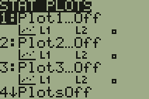
- Press the 1 key and then Enter. | 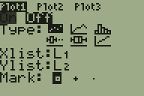
- Use the left-arrow key to highlight On | 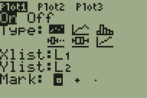
- Use the down-arrow key to move to Type. Then use the right-arrow key to choose the histogram icon (last item on top row). Press Enter. | 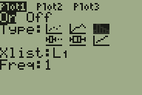
- Use the down-arrow key to move to Xlist. Enter the correct list if it is not already shown.
- Make sure Freq is set to 1

- Make a default histogram

- Press the Zoom key (top row, middle). | 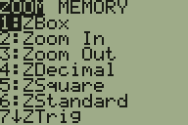
- Use the down-arrow key to scroll down to 9 (ZoomStat). | 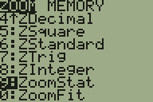
- Press Enter. A default histogram is displayed. | 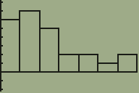

- Investigate the histogram
- Press the Trace key (top row). This will place an icon at the top of the first bar.  In this case, the text below tells us that the bar begins at 0 and ends at 6.5 (less than) and that the bar is 6 units high. Thus, there are 6 data values in $0≤x<6.5$ | 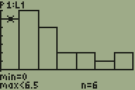
- Use the right-arrow key to scroll to the next bar.  In this case, the text below tells us that the bar begins at 6.5 and ends at 13 (less than) and that the bar is 7 units high. Thus, there are 7 data values in 6.5$≤x<13$ | 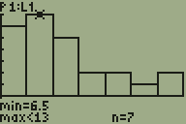
- Continue scrolling to the right to investigate each of the bars.

- Customize the histogram. Suppose we want a histogram with 5 bars. We can use the descriptive statistics to see that the minimum value is 0 and the maximum value is 39. Thus, we might want the histogram to span 0 to 40 with 5 bars. Thus, we would have a bar width of $\frac{40-0}{5}=8$.

- Press the WIndow key (top row). | 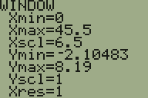
- Use the arrow keys and numbers to change these values:  Xmin = 0  Xmax = 40  Xscl = 8  Note that Xscl is the bar width.  Do not change any of the other values. | 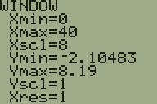
- Press the Graph key (top row, far right) to display the customized histogram.  Use the Trace key to investigate. | 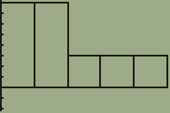

- Suppose I ask you to draw a relative frequency histogram with the axes properly labeled. Tracing the histogram we can build this chart:

 | Frequency Distribution | Relative Frequency Distribution
Class | Frequency (count) | Relative Frequency
(0,8) | 8 | 8/25 = 0.32 = 32%
[8, 16) | 8 | 8/25 = 0.32 = 32%
[16, 24) | 3 | 3/25 = 0.12 = 12%
[24, 32) | 3 | 3/25 = 0.12 = 12%
[32, 40) | 3 | 3/25 = 0.12 = 12%
 | n = 25 | sum = 100%

Then, the corresponding relative frequency histogram is:

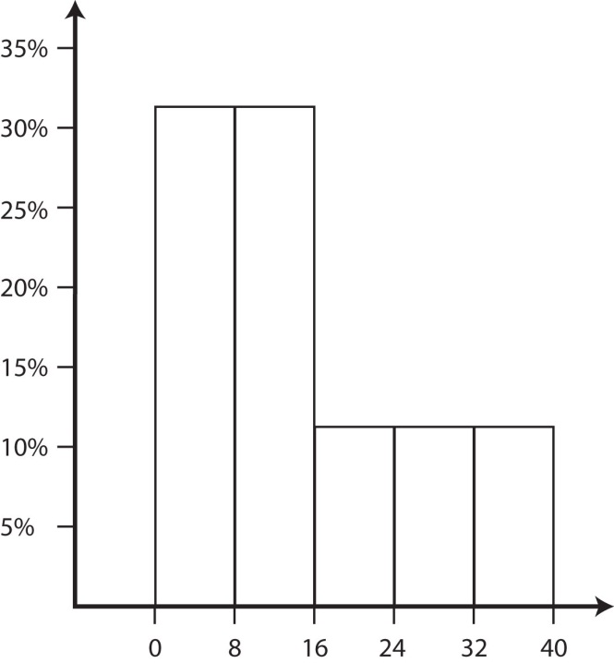

- After you have modified the window settings, if you then go back and press the Zoom and 9 keys (displaying the default histogram), then this will reset the window settings.

- If you graph does not display correctly, try these things to fix it:

- Press the Y= key (top row). There should be nothing to the right of any of the equals signs. If there is, delete it. | 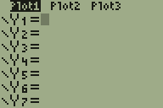
- Choose Stat Plot by pressing the 2nd key and then the Y= key. Make sure Plot 1 is On and all other Plots are Off. | 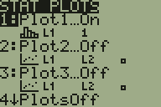

Homework 2.6

- Use your calculator to draw a histogram from the data in Homework 2.2 using 5, 6, and 7 classes for both men’s and women’s data. Sketch each histogram on paper with properly labeled axes.

2.10 – Histogram Shapes and Skew

- Common Shapes of Distributions – To determine the shape of a distribution, we sketch a curve over the histogram and analyze the curve.

Symmetric, Bell-Shaped – Most of the data is towards the center but curve falls off rapidly in the larger and smaller directions. | 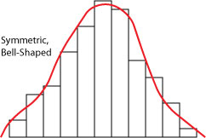
Right Skewed – Most of the data have small values but there are a few large data values | 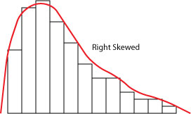
Left Skewed – Most of the data have large values but there are a few small values. | 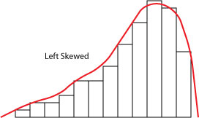
Symmetric, Uniform – Small, medium, and large data values occur with similar frequencies. | 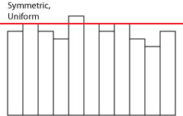
Bimodal – There are two distinct peaks in the data. This is not very common. Sometimes when we have bimodal data, we have inadvertently sampled from two populations. | 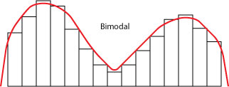

- Examples

Example - 2 Bedroom Apartment Prices in Atlanta, Ga. This data was collected in April, 1995 from the Creative Loafing, a free, weekly newspaper in Atlanta. All 2 bedroom advertisements were included. Most of the apartments (about 90%) are between $475 and $925; however, there are a few with much higher prices.

Skewed Right

Example - New release CD prices. Most CD’s (about 65%) cost between $14.40 and $16.80; however there are a few with lower prices. This could be due to large department stores using new release CD’s as loss leaders.

Skewed Left

Example - Time (seconds) it takes a worker to assemble a part on an assembly line. The time to assemble a part is fairly uniform over the range 15 seconds to 20 seconds.

Symmetric, Uniform

Example - Total bill ($) at a small grocery store. Perhaps there are a number of people who just stop in to buy a few items (lower total bill) and a similar number of people who shop for a week (higher grocery bill). Thus, perhaps there are two populations represented here: quick stop shoppers and weekly shoppers.

Bimodal

Homework 2.7

- Describe the distribution of the men’s and women’s data using the histograms from Homework 2.6.

2.11 – Making an Ogive

- Cumulative Relative Frequency – The percentage of data that have values below the upper class limit for a class.

- Ogive - A graph of the cumulative relative frequencies. This graph shows how the classes/bars add up.

- Example – Consider the salary data previously considered:

Class | Frequency (count) | Relative Frequency | Cumulative Relative Frequency
(18,22) | 1 | 1/50 = 0.02 = 2% | 2%  of salaries are less than $22,000 $$22,000
[22, 26) | 4 | 4/50 = 0.08 = 8% | 2% + 8% = 10%  of salaries are less than $26,000
[26, 30) | 8 | 8/50 = 0.16 = 16% | 10% + 16% = 26%  of salaries are less than $30,000
[30, 34) | 23 | 23/50 = 0.46 = 46% | 26% + 46% = 72%  of salaries are less than $34,000 $$22,000
[34, 38) | 10 | 10/50 = 0.20 = 20% | 72% + 20% = 92%  of salaries are less than $38,000 $$22,000
[38, 42) | 4 | 4/50 = 0.08 = 8% | 92% + 8% = 100%  of salaries are less than $42,000 $$22,000
 | n = 50 | sum = 100%

To compute the cumulative relative frequencies shown in the table above, we simply ask ourselves a series of questions: what percentage of salaries are:  - less than 22? Answer: the height of the first bar in the histogram (shown at right), 2%.  - less than 26? Answer: the height of the first two bars in the histogram, 2% + 8% = 10%. | - less than 30? Answer: the height of the first three bars in the histogram, 2% + 8% + 16% = 26%.  etc.
Finally, we graph the cumulative relative frequencies to obtain the Ogive as shown in the figure below:

- We graph the upper class limit with the corresponding cumulative relative frequency for eah class. For instance, we graph, (22,2), (26,10), (30, 26), (34, 72), (38, 92), (42, 100).

- We go back and plot the lower class limit for the first class with the value 0. For instance, we plot (18,0).

- Connect the dots with a smooth curve.

Homework 2.8

- Choose a men’s and women’s histogram from Homework 2.6 and draw an ogive for each.

2.12 – Interpreting a Histogram and Ogive

- The height of a bar in a histogram tells the percentage of data that falls between the lower and upper limits of the bar.

- The height at some point along the curve of an ogive represents the percentage of data that is less than the value on the x-axis that is directly below the point on the curve.

- Example - Consider the histogram shown below which describes the speed of a sample of gazelles.

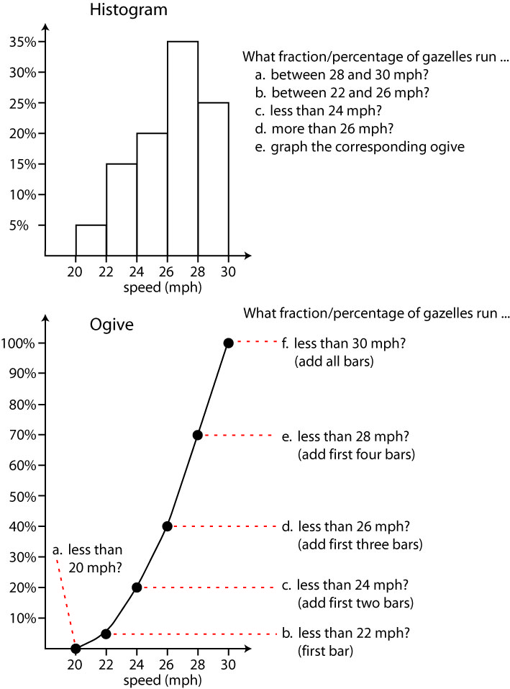

- Example - Consider the ogive shown below which describes the salary of mid-career graphic artists.

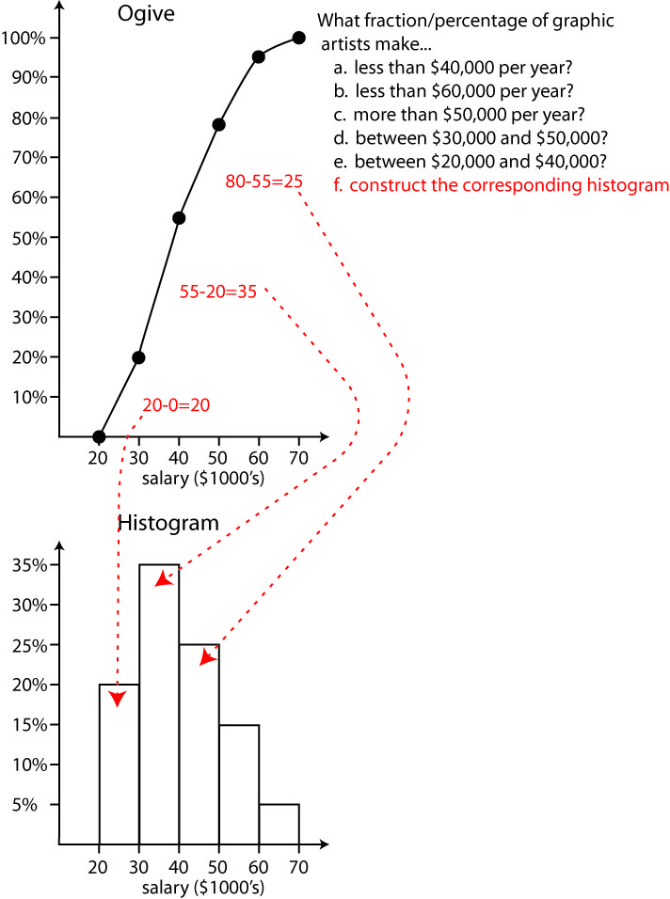

Homework 2.9

- Consider the histogram shown below which summarizes the total amount of money that was received by a restaurant (revenue) on 40 Friday nights. What percentage of Friday nights have revenue of (a) $4900 to $5050, (b) less than $4600, (c) more than $4750? (d) Graph the corresponding ogive.

- Consider the ogive shown below that summarizes the speeds of a random selection cars along a stretch of highway with a posted speed limit of 55 mph . Guidelines specify that cars traveling 57 mph or less are not speeding, cars traveling more than 57 mph and up to 67 mph are classified as Class 1 Speeding, while those traveling more than 67 mph are classified as Class 2 Speeding. What percentage of cars are (a) not speeding, (b) Class 1 Speeding, (c) Class 2 speeding. (d) Draw the corresponding Histogram

2.13 – Detecting Skew Numerically

- Detecting Skew Numerically – The difference between the mean and the median tells us about the skew of the data as the table below shows. The larger the difference, the more skew in the data. If there is little difference, the data has a symmetric distribution. We remember that outliers influence the mean more than the median. So, if the mean is larger than the median then the sample probably has some extra large data values and the histogram will appear skewed right. If the mean is smaller than the median then the sample probably has extra small data values and the histogram will appear skewed left.

Mean – Median |  | Interpretation
negative | $\overline{x}<M$ | Left Skew
about zero | $\overline{x}≈M$ | Symmetric
positive | $\overline{x}>M$ | Right Skew

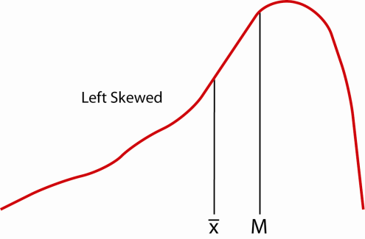 | 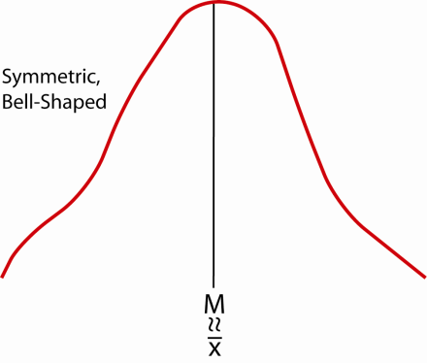 | 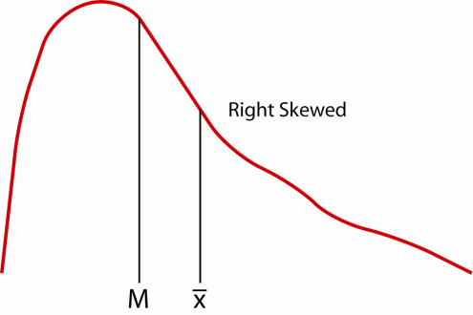

It does take a bit of judgment to determine if the difference between the Mean and Median is close to zero. Detailed knowledge of the problem at hand is useful in detecting skew numerically.

- Example – Estimation of skew using the mean and median from three examples considered earlier. The values of the percentage differences cannot be used to make judgments about the skew, but are used here for comparison purposes.

Data | Mean | Median | Difference | % Difference | Skew
Salaries | $32,048.00 | $32,150.00 | -$102.00 | -0.3% | Symmetric
Rent | $706.70 | $675.00 | $31.70 | +4.7% | Right
CD Price | $14.65 | $15.01 | -$0.36 | -2.4% | Left

For comparison, the histograms are shown below:

- Example – Estimation of skew using the mean and median from 5-Word Word Search Problem. Men and Women VSU students were timed as described in Chapter 1. The statistics shown below were generated by Minitab.

As the table below shows, the women’s data shows that the mean is about 13.9% larger than the median while the men’s data shows that the mean is 34.2% larger than the median. Thus, we would expect both data sets to be skewed to the right with a much heavier skew in the men’s data.

Data | Mean | Median | Difference | % Difference | Skew
Women | 93.49 | 82.09 | 11.4 | 13.9% | Right
Men | 121.60 | 90.60 | 31.0 | 34.2% | Right

For comparison, the histograms are shown below. Both histograms show strong right skew.

Homework 2.10

- Compare the mean and median from the results of Homework 2.3 and compare to the corresponding histograms from Homework 2.7.

- The median weight of an apple is 5.6 oz. and the average is 6.5 oz. What type of skew is present?

- The average gas mileage for a Nissan Pathfinder is 15.6 mpg and the median is 17.2 mpg. What type of skew is present?

- Which sample has the (a) least skew, (b) most skew, (c) most left skew, (d) most right skew, (e) least left skew, (f) least right skew, (g) most symmetry, (h) least symmetry?

Sample | Average | Median
1 | 27.4 | 25.3
2 | 128.6 | 130.2
3 | 67.33 | 63.1
4 | 20.2 | 28.6

2.14 – Empirical Rule

- Empirical Rule – If data is bell-shaped (mound-shaped), then Empirical Rule states that:

- Approximately 68% of data should fall within $±$ 1 standard deviation of the average, $\overline{x}±1s$
- Approximately 95% of data should fall within $±$ 2 standard deviations of the average, $\overline{x}±2s$
- Approximately 99.7% (i.e. almost all) of the data should fall within $±$ 3 standard deviations of the average, $\overline{x}±3s$

- Diagrams of 68% rule and 95% rule:

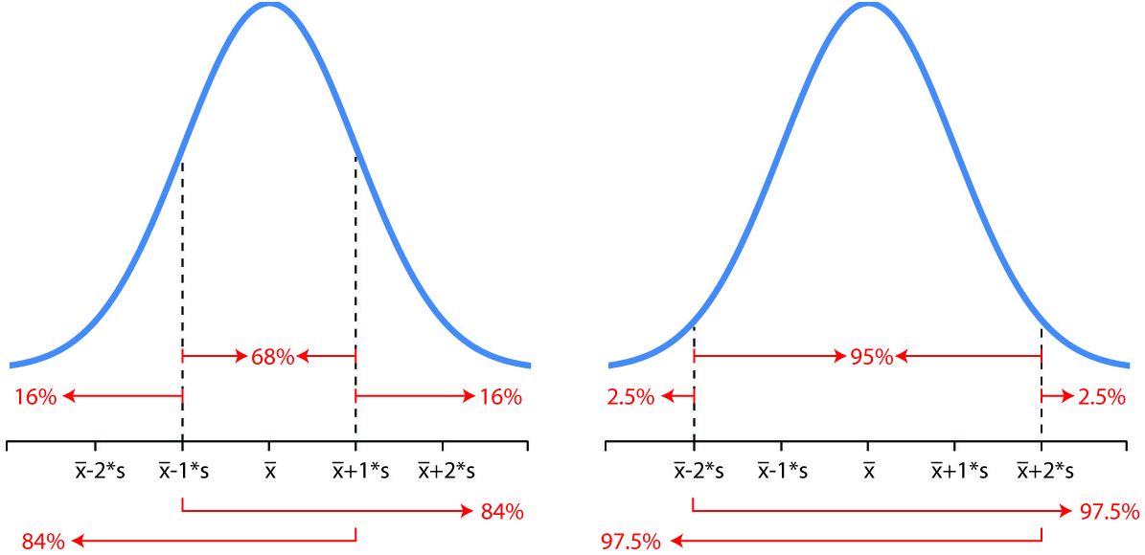

- In the “68%” graph on the left, we see where the center 68% of the data should fall. Remembering that the graph must show 100% of the data, we see that 100%-68%=32%. Now, this left over 32% should be split equally between the two tails, 16% each. Thus, 68% rule allows us to break the data up into three groups: 16%, 68%, 16%. We also note that 16%+68%=84%, so that the 68% rule also breaks the data into 84%, 16% and 16%, 84%.

- The “95%” graph on the right shows that the data can be broken up into these sets: 2.5%, 95%, 2.5%; and 9 7.5%, 2.5%; and 2.5%, 97.5%.

- Example – The distribution of the weight of men is bell-shaped with a mean (average) of 170 lbs. and standard deviation of 20 lbs.

- 68% of men have weight between what two values?  - 16% of men have weight below what value?  - 84% of men have weight above what value?  - 16% of men have weight above what value?  - 84% of men have weight below what value?  - 50% of men have weight below what value?  - 95% of men have weight between what two values?  - 2.5% of men have weight below what value?  - 97.5% of men have weight above what value?  - 2.5% of men have weight above what value?  - 97.5% of men have weight below what value?  - 99.7% of men have weight between what two values? | What percentage of men have weight...  - between 150 lbs. and 190 lbs?  - more than 150 lbs.?  - less than 150 lbs.?  - more than 190 lbs.?  - less than 190 lbs.?  - more than 170 lbs.?  - between 130 lbs. and 210 lbs.?  - less than 210 lbs?  - less than 130 lbs?  - more than 130 lbs?  - more than 210 lbs?  - between 110 lbs. and 230 lbs.?

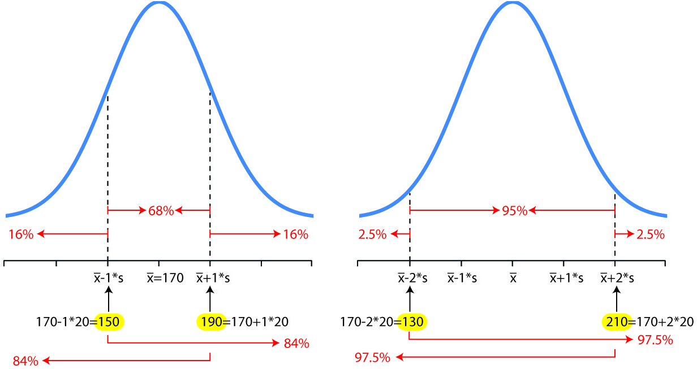

Homework 2.11

- Consider the data from Homework 2.3. Does the Empirical Rule apply for either data set? If so, calculate the actual percentage of data that falls with one standard deviation of the average. Also, calculate for two and three standard deviations. Make a chart of these values. In other words, calculate the boundaries for the 68% empirical rule. Next, pull the data up and then count the number of data values that fall in this range, then make this a percentage by dividing by the sample size. Now, repeat for the other two empirical rules. In a sense you are “testing” the empirical rule against one of your data sets.

- The average price of a used Cadillac manufactured in 2003 is $22,000 with a standard deviation of $3000. The distribution of used Cadillac prices is bell-shaped. What percentage of Cadillac’s cost...

  - less than $19,000?
  - less than $25,000?
  - less than $22,000?
  - more than $19,000?
  - more than $25,000?
  - more than $28,000?
  - more than $16,000?
  - less than $28,000?
  - less than $16,000?
  - between $16,000 and $28,000?
  - between $19,000 and $25,000?
  - between $13,000 and $31,000?

- The average time it takes a worker to perform a task on an assembly line is 38 seconds with a standard deviation of 4 seconds. The distribution of times is bell-shaped.

  - 2.5% of the time, a worker takes more than _____ seconds.
  - 2.5% of the time, a worker takes less than _____ seconds.
  - 68% of the time, a worker takes a time between ____ seconds and _____ seconds.
  - 84% of the time, a worker takes less than _____ seconds.
  - 97.5% of the time, a worker takes more than _____ seconds.
  - 50% of the time, a worker takes more than _____ seconds.
  - 84% of the time, a worker takes more than _____ seconds.
  - 95% of the time, a worker takes a time between _____ second and _____ seconds.
  - Almost all workers take between ____ seconds and _____ seconds.

2.16 – Making a Box Plot

- Box Plot - A Box plot is a graphical summary of quantitative data. Similar to the histogram, it shows the center, spread, and skew of the data. It is a graph of the first and third quartiles, the median, fences, whiskers, and outliers.

- Steps to Make a Box Plot

  - Compute: $Q_{1}, M, Q_{3}, IQR$

  - Compute fence locations:

${Lower Fence= Q}_{1}-1.5*IQR$
${Upper Fence= Q}_{3}+1.5*IQR$

  - Determine whisker locations. As shown in the figure below, the whiskers are the lines coming out of either end of the box. The left whisker extends to the smallest value inside the lower fence and the right whisker extends to the largest value inside the upper fence.

  - Determine whether there are any outliers. Any values outside the fences are outliers and are marked with a symbol, for instance, “*”.

  - Draw the box plot as shown in the figure below. Note that the fences are usually not actually drawn, they are just understood to be there. Below, we have drawn them as dashed lines simply for emphasis.

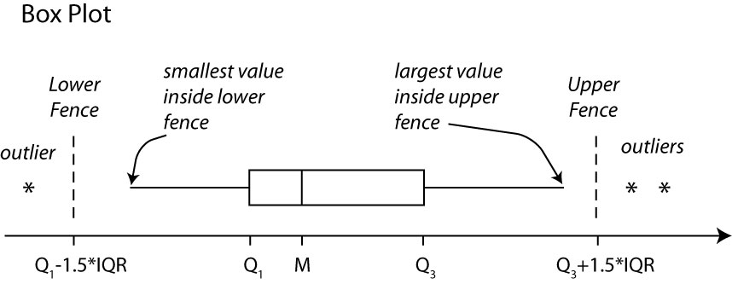

Note that an alternate form of the boxplot draws the left whisker all the way to the minimum and the right whisker to the maximum value. We will not use this approach.

- Example – This CS starting salary data was considered previously.

19.5 | 26.8 | 29.1 | 30.5 | 31.5 | 32.2 | 33.2 | 33.9 | 35.4 | 37.4
24.2 | 27.4 | 29.1 | 30.9 | 31.9 | 32.4 | 33.3 | 34.8 | 36.1 | 39.2
24.8 | 27.8 | 29.6 | 30.9 | 32.1 | 32.5 | 33.3 | 34.9 | 36.1 | 39.7
25.3 | 27.8 | 30.1 | 31.1 | 32.1 | 32.8 | 33.4 | 35.0 | 36.3 | 40.2
25.7 | 28.6 | 30.3 | 31.4 | 32.1 | 33.1 | 33.4 | 35.3 | 36.9 | 41.0

To make a box plot:

- Calculate: $Q_{1}, M, Q_{3}, IQR$ (see Section 2.6, items 3 and 4 if necessary)

$Q_{1}=29.6, M=32.15, Q_{3}=34.9, IQR=34.9-29.6=5.3$

- Compute fence locations:

${Lower Fence= Q}_{1}-1.5*IQR=29.6-1.5*5.3=21.65$
${Upper Fence= Q}_{3}+1.5*IQR=34.9+1.5*5.3=42.85$

- Determine Whisker Locations:

Lower = 24.2 (smallest value more than 21.65)
Upper = 41.0 (largest value less than 42.85)

- Determine whether there are any outliers: There is one outlier, 19.5 which is below the Lower Fence, 21.65

- Draw Box Plot as shown below (fences shown as dashed lines, for emphasis):

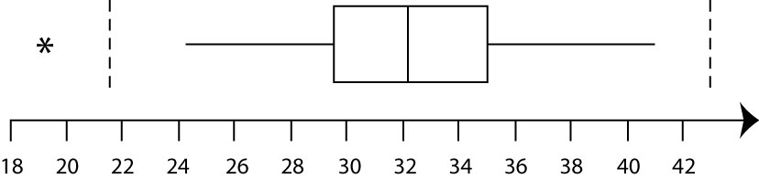

- Box Plot Example - A sample of the speed of cars on an interstate reveals that: $Q_{1}=65, M=67, Q_{3}=71$. (a) Construct a Box Plot (we will not be able to put the whiskers on the Box Plot because we do not have the actual data). (b) Draw the fences. (c) Would these speeds be considered outliers: 75, 70, 53, 82, 77? Classify these data values as Possible Outliers (O) or Not an Outlier (N) using the Box Plot.

Homework 2.13

- Consider the data in Homework 2.2. Build a Box plot by hand for each dataset. Hint: first compute the numerical descriptive statistics on your calculator.

2.17 – Box Plot Shapes and Skew

This section provides guidelines for determining symmetry or skewness in a Box Plot:

- If whiskers are approximately the same length and median is approximately in the middle of the box then the the data is symmetric. If the box is significantly thinner than the whiskers, then this is an indication that the data may be bell-shaped. If the whiskers and each half of the box are similar in size, then the data may be more uniform in distribution.

Symmetric, bell-shaped, no outliers | Symmetric, uniform, no outliers

What if there is exactly one outlier? Sometimes, we ignore it, unless it is very large (or small). So, in the examples below, we would say that this data is symmetric.

Symmetric, probably bell shaped, 1 outlier on the low side | Symmetric, bell shaped, 1 outlier on the low side

What if there are several outliers? If there are a roughly equal number of small and large outliers, at similar distances from the whiskers, I usually would say that this data is symmetric as in the example on the left. However, on the right is a case where we would probably say that the data is right skewed, thus we are influenced by the three outliers on the high side.

Symmetric, bell shaped, 2 outliers on the low side and three on the high side | Right Skewed, 3 outliers on the high side.

- If the whiskers are distinctly different lengths or the median is not in the middle of the box, then the data is skewed. If the length to the right of the median is longer than the the length to the left of the median, then the data is right skewed, otherwise it is left skewed.

Right Skew, no outliers | Right Skewed, no outliers | Right Skewed, no outliers

- If the whiskers are different lengths and the median is not in the middle of the box, then the data is usually highly skewed.

Strong Left Skew, no outliers | Strong Right Skew, no outliers

- Example – When we are comparing two samples, we usually make the two box plots on the same graph so that we can compare them. The two box plots below are for the word search problem discussed earlier. We could summarize this data as follows:

The median for the men’s data is larger than the women’s data, though it is hard to see from the graph, unless closely inspected. Thus, there is some indication that men take longer than women. From the graph, these medians appear to be about 80 and 90 seconds, respectively. The men’s data has more spread than the women’s data as measured by the range (estimated from graph). We also see that the men’s data is more skewed than the women’s data. The men’s box plot shows that about 25% of men took longer than 3 minutes (180 seconds), while a smaller fraction of the women took this long (less than 25%). There were no outliers indicated by the box plots for either the men’s or women’s data.

Homework 2.14

- Compare (center, spread, skew, outliers) the box plots from Homework 2.14.

Consider the box plots shown below to answer next three questions.

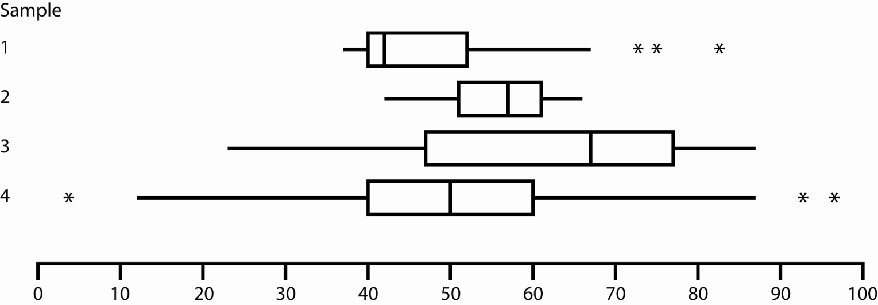

- Which sample has the  - most variability?  - least variability?  - most skew?  - least skew?  - largest percentage of data greater than 50?  - largest percentage of data greater than 70?  - largest median?  - smallest median?  - smallest first quartile?  - largest first quartile?  - Classify the skew of each sample  - most right skew?  - most left skew? | - Which statement is correct?  - The median of Sample 1 is about the same as the first quartile for Sample 2  - The IQR for Sample 4 is larger than the IQR for Sample 3  - Half of the data in Sample 3 is larger than all the data in Sample 2  - At least 25% of the data in Sample 4 is larger than all the data in Sample 2
- Consider Sample 2. The fence on the high side is located at what value (approximately)? | - Which sample has the most variability in the center-most 50% of the data?
- Which sample has a mean that is significantly larger than its median?

2.18 – Making a Box Plot on TI-83 Calculator

The steps below show how to use the TI 83/84 calculator to construct a box plot that shows outliers. Assume that you have a dataset in L1. Next,

- Enter this data in L1 (or some other list):

7, 39, 13, 9, 25, 8, 22, 0, 2, 18, 2, 30, 7, 35, 12, 15, 8, 6, 5, 29, 0, 11, 39, 16, 15

- Enter this data in L1 (or some other list):

- Choose: Stat Plot by pressing the 2nd key and then they Y= (upper left, top row) key.
- Press the 1 key and then Enter.
- Use the left-arrow key to highlight On, if necessary, and press Enter.
- Use the down-arrow key to move to Type. Then use the right-arrow key to choose the first box plot icon (1st item on second row. Press Enter. | 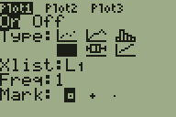
- Use the down-arrow key to move to Xlist. Enter the correct list if it is not already shown.
- Ignore Mark, one should be selected. This is the symbol that will be used to display any outliers.
- Display the boxplot

- Press the Zoom key (top row, middle).
- Use the down-arrow key to scroll down to 9 (ZoomStat).
- Press Enter. The boxplot is displayed. | 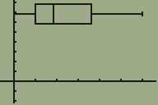

- Investigate the boxplot

- Press the Trace key (top row). This will place an icon on the extreme left of the boxplot, either an outlier or the end point of the left whisker.  In this case, the text below tells us that endpoint of the left whisker is the minimum data value and has the value 0. | 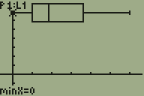
- Use the right-arrow key to scroll to the right. Information on the next item is displayed.  In this case, the text below tells us that the first quartile is 6.5. | 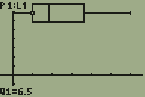
- Continue scrolling to the right to reveal the value of the median, third quartile, endpoint of the right whisker, and outliers if there are any.

- Suppose I ask you to draw a boxplot with the axes properly labeled from this graph.

Tracing the boxplot, we arrive at:

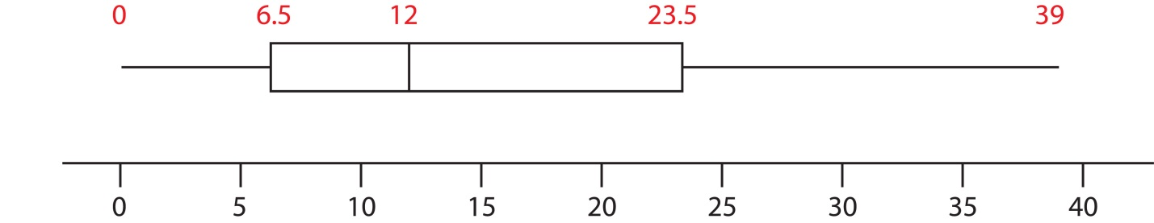

- If you graph does not display correctly, try these things to fix it:

- Press the Y= key (top row). There should be nothing to the right of any of the equals signs. If there is, delete it.

- Choose Stat Plot by pressing the 2nd key and then the Y= key. Make sure Plot 1 is On and all other Plots are Off.

Homework 2.15

- Consider the data from Homework 2.3. Use your calculator to make a box plot of each data set.

2.20 – Z-scores

- Z-score – A z-score can be calculated for each data value. It is a way of standardizing a data value so that we can get a relative view of how large or small it is. If you calculate the z-score for each item in a sample, then the resulting z-scores will have mean 0 and standard deviation 1. In general, we can calculate a z-score for each data value:
$$z_{i}=\frac{x_{i}-\overline{x}}{s}, i=1,2,⋯,n$$
Note that we take each data value, subtract the center () and divide by the spread (s).

- Interpretation: a z-score is the number of standard deviations that a data value is away from the mean. If the z-score is negative, then it tells the number of standard deviations that the data value is below the mean. If the z-score is positive, then it tells the number of standard deviations that the data value is above the mean.

Example – Suppose a data set has an average of 20 and standard deviation of 5.

- The data value 30 has z-score of 2: $z=\frac{x-\overline{x}}{s}=\frac{30-20}{5}=2$

Thus, we see that the value 30 is 2 standard deviations above the mean:

.

- The data value 15 has z-score -1: $z=\frac{x-\overline{x}}{s}=\frac{15-20}{5}=-1$.

Thus, the data value 15 is 1 standard deviation below the mean:

.

- Z-scores and Outlier Detection – If a z-score is greater than three in absolute value, then it is a possible outlier.

If $\left|z\right|>3$ then $x$ is a Possible Outlier.

Where does this rule come from? If the data is bell-shaped, then the Empirical Rule applies. In this case, a z-score greater than two in absolute value may be an outlier as we remember that the Empirical Rule states that only 5% of the time will a value fall outside . Also, remember that only 0.3% of the time will a value fall outside . Thus, a z-score greater than 3 in absolute value is an even stronger indicator of an outlier, in the presence of symmetric data. For this course, we will use the value 3.

- Z-score Examples

- Example – Consider the word search problem considered previously which compares men and women to see how long they take to solve the problem. The (partial) descriptive statistics are repeated here:

Variable N Mean StDev
Women 50 93.49 60.35
Men 50 121.6 76.70

The data and z-scores are shown below:
  Women | Men | z-Women | z-Men
  20.2 | 25.6 | -1.2 | -1.3
  20.8 | 30.6 | -1.2 | -1.2
  24.5 | 34.8 | -1.1 | -1.1
  24.8 | 35.6 | -1.1 | -1.1
  26.2 | 35.9 | -1.1 | -1.1
  28.9 | 41.5 | -1.1 | -1.0
  33.3 | 40.8 | -1.0 | -1.1
  36.2 | 44.8 | -0.9 | -1.0
  34.0 | 45.1 | -1.0 | -1.0
  40.3 | 45.9 | -0.9 | -1.0
  39.1 | 55.6 | -0.9 | -0.9
  39.7 | 53.3 | -0.9 | -0.9
  38.8 | 54.6 | -0.9 | -0.9
  41.6 | 57.2 | -0.9 | -0.8
  45.5 | 58.9 | -0.8 | -0.8
  46.0 | 64.9 | -0.8 | -0.7
  46.6 | 63.2 | -0.8 | -0.8
  50.5 | 75.2 | -0.7 | -0.6
  50.2 | 74.7 | -0.7 | -0.6
  53.6 | 76.2 | -0.7 | -0.6
  60.3 | 80.0 | -0.6 | -0.5
  59.6 | 85.8 | -0.6 | -0.5
  59.9 | 88.9 | -0.6 | -0.4
  59.4 | 91.3 | -0.6 | -0.4
  79.0 | 89.5 | -0.2 | -0.4
  Women | Men | z-Women | z-Men
  85.2 | 89.9 | -0.1 | -0.4
  88.5 | 99.1 | -0.1 | -0.3
  96.7 | 105.9 | 0.1 | -0.2
  100.0 | 107.8 | 0.1 | -0.2
  105.5 | 120.6 | 0.2 | 0.0
  104.2 | 129.2 | 0.2 | 0.1
  103.7 | 151.7 | 0.2 | 0.4
  113.5 | 160.4 | 0.3 | 0.5
  122.1 | 166.0 | 0.5 | 0.6
  119.6 | 169.2 | 0.4 | 0.6
  120.9 | 180.3 | 0.5 | 0.8
  124.6 | 181.0 | 0.5 | 0.8
  128.0 | 185.7 | 0.6 | 0.8
  149.0 | 191.2 | 0.9 | 0.9
  154.0 | 199.5 | 1.0 | 1.0
  164.9 | 199.9 | 1.2 | 1.0
  169.5 | 208.6 | 1.3 | 1.1
  180.9 | 208.1 | 1.4 | 1.1
  179.1 | 226.7 | 1.4 | 1.4
  184.7 | 227.9 | 1.5 | 1.4
  189.9 | 240.7 | 1.6 | 1.6
  200.6 | 251.2 | 1.8 | 1.7
  198.7 | 255.5 | 1.7 | 1.7
  210.3 | 271.1 | 1.9 | 1.9
  221.4 | 300.9 | 2.1 | 2.3

When the data is sorted (as above), it is easy to look for outliers using z-scores. We simply scan the beginning and end of the list looking for z-scores of more than 3 in absolute value. In this case, we see that there are no outliers indicated by the z-scores. We see that the smallest men’s and women’s data values have z-scores of -1.2 and -1.3, respectively. The largest data values have z-scores of 2.1 and 2.3, respectively. In this case, the results are the same as when we looked at the boxplots (Section 2.17): no outliers. In general, this is not the case. Box plots will show outliers more frequently than z-scores. For a data value to be an outlier with respect to z-scores, it must really be large (or small).

- Example - In a class of 32 students the average test score was 70 with a standard deviation of 10. Would a score of 45 be considered an outlier?

- Example – A machine produces bolts with an average diameter of 10 mm and standard deviation of 1/4 mm. (a) Would a bolt with diameter 10.5 mm be considered an outlier? (b) Would a bolt with diameter 10.8 mm be considered an outlier?

- Comparing Things Measured on Different Scales - Z-scores are useful to compare things measured on different scales. For instance, suppose that one person scored a 550 on the quantitative portion of the SAT and another scored 14 on the mathematics portion of the ACT test. How would we determine who got the higher score? The solution is to use z-scores.

Similarly, how would be determine when it was much hotter it is in Fairbanks, Alaska than it is in Valdosta, Georgia, relatively. The two cities have different average temperatures (and standard deviations) so how would be compare a temperature of 75 in Fairbanks and 90 in Valdosta in May? The solution, again, is to use z-scores.

- Example - The mean score on the SAT-Quantitative is 500 with a standard deviation of 50. The mean score on the ACT-Quantitative is 11 with a standard deviation of 2. Jane score 550 on the SAT and Mary scored a 14 on the ACT. Which person got the higher score?
,
So we see that Jane scored 1 standard deviation above the average and Mary scored 1.5 standard deviations above the average. Thus, Mary had the higher score.

- Example - The average high temperature in Fairbanks, AK in January is -1 with a standard deviation of 10. The average high temperature in Valdosta, GA is 62 degrees with a standard deviation of 5 degrees. In relative terms, which would city would be colder: Fairbanks at -12 degrees or Valdosta at 51 degrees?
,
Thus, Fairbanks is 1.1 standard deviations below the average and Valdosta is 2.2 standard deviations below the average. Thus, Valdosta is colder in relative terms.

Homework 2.16

- Use the data from Homework 2.1 to find the z-scores of the smallest and largest data values. Are there outliers? Does this correspond with what the box plots revealed?
- Consider this data: 4.5, 6.2, 8.2, 9.1, 10.2, 10.5, 11.7, 11.9, 13.4. The data value 8.2 is how many standard deviations away from the mean? It is above or below the mean?
- The average on a Biology exam is 63 with a standard deviation of 10. The average on a Math exam is 148 with a standard deviation of 30. Bob scores a 73 on the Biology exam and 168 on the Math exam. Which exam did he score higher on, relative to the rest of the class?

